**Case Study #1 - Danny's Diner**

Danny Ma · May 1, 2021

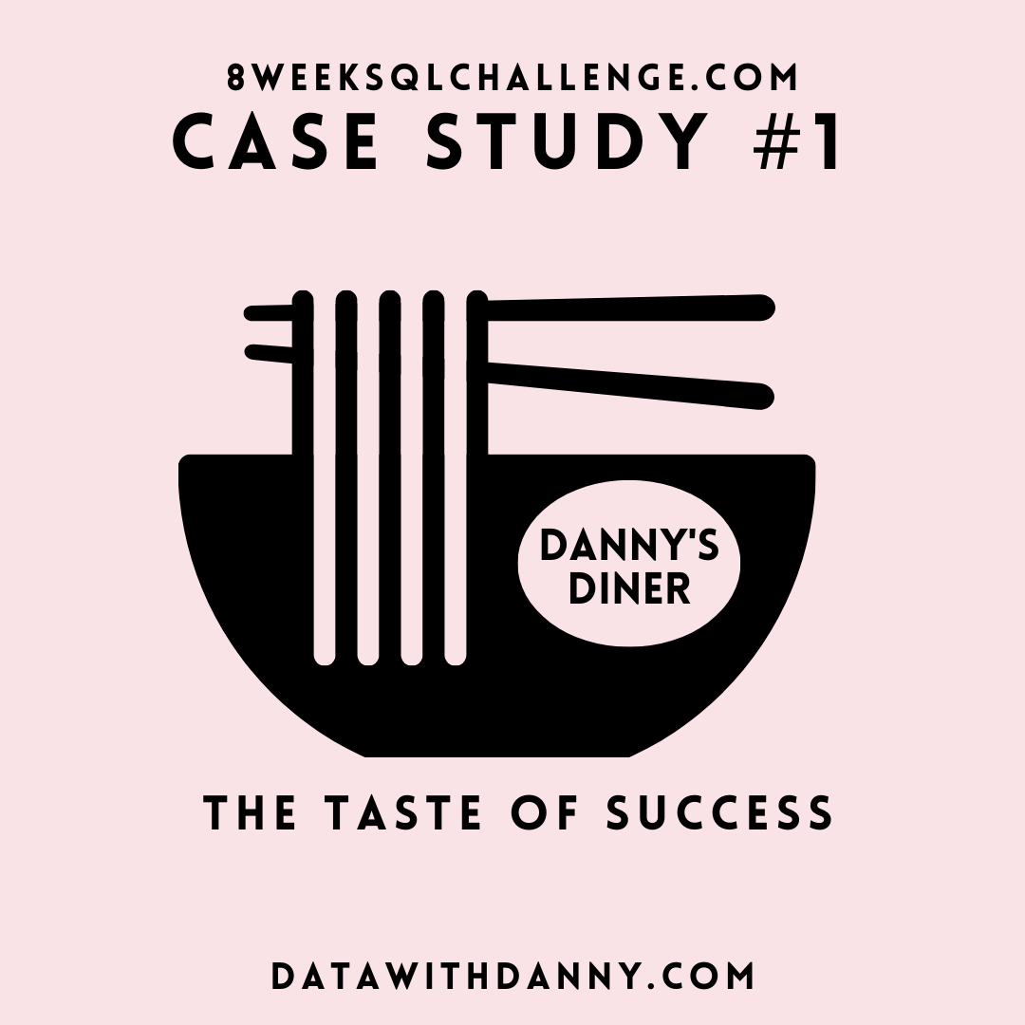

**Introduction**

Danny seriously loves Japanese food so in the beginning of 2021, he decides to embark upon a risky venture and opens up a cute little restaurant that sells his 3 favourite foods: sushi, curry and ramen.

Danny’s Diner is in need of your assistance to help the restaurant stay afloat - the restaurant has captured some very basic data from their few months of operation but have no idea how to use their data to help them run the business.

**Problem Statement**

Danny wants to use the data to answer a few simple questions about his customers, especially about their visiting patterns, how much money they’ve spent and also which menu items are their favourite. Having this deeper connection with his customers will help him deliver a better and more personalised experience for his loyal customers.

He plans on using these insights to help him decide whether he should expand the existing customer loyalty program - additionally he needs help to generate some basic datasets so his team can easily inspect the data without needing to use SQL.

Danny has provided you with a sample of his overall customer data due to privacy issues - but he hopes that these examples are enough for you to write fully functioning SQL queries to help him answer his questions!

Danny has shared with you 3 key datasets for this case study:

* sales
* menu
* members

You can inspect the entity relationship diagram and example data below.

**Entity Relationship Diagram**

**Example Datasets**

All datasets exist within the dannys_diner database schema - be sure to include this reference within your SQL scripts as you start exploring the data and answering the case study questions.

**Table 1: sales**

The sales table captures all customer_id level purchases with an corresponding order_date and product_id information for when and what menu items were ordered.

| **customer_id** | **order_date** | **product_id** |
| --- | --- | --- |
| A | 2021-01-01 | 1 |
| A | 2021-01-01 | 2 |
| A | 2021-01-07 | 2 |
| A | 2021-01-10 | 3 |
| A | 2021-01-11 | 3 |
| A | 2021-01-11 | 3 |
| B | 2021-01-01 | 2 |
| B | 2021-01-02 | 2 |
| B | 2021-01-04 | 1 |
| B | 2021-01-11 | 1 |
| B | 2021-01-16 | 3 |
| B | 2021-02-01 | 3 |
| C | 2021-01-01 | 3 |
| C | 2021-01-01 | 3 |
| C | 2021-01-07 | 3 |

**Table 2: menu**

The menu table maps the product_id to the actual product_name and price of each menu item.

| **product_id** | **product_name** | **price** |
| --- | --- | --- |
| 1 | sushi | 10 |
| 2 | curry | 15 |
| 3 | ramen | 12 |

**Table 3: members**

The final members table captures the join_date when a customer_id joined the beta version of the Danny’s Diner loyalty program.

| **customer_id** | **join_date** |
| --- | --- |
| A | 2021-01-07 |
| B | 2021-01-09 |

**Interactive SQL Session**

You can use the embedded DB Fiddle below to easily access these example datasets - this interactive session has everything you need to start solving these questions using SQL.

You can click on the Edit on DB Fiddle link on the top right hand corner of the embedded session below and it will take you to a fully functional SQL editor where you can write your own queries to analyse the data.

You can feel free to choose any SQL dialect you’d like to use, the existing Fiddle is using PostgreSQL 13 as default.

Serious SQL students have access to a dedicated SQL script in the 8 Week SQL Challenge section of the course which they can use to generate relevant temporary tables like we’ve done throughout the entire course!

**CREATE** **SCHEMA** dannys_diner;

**SET** search_path = dannys_diner;

**CREATE** **TABLE** sales (

"customer_id" VARCHAR(1),

"order_date" DATE,

"product_id" INTEGER

);

**INSERT** **INTO** sales

("customer_id", "order_date", "product_id")

**VALUES**

('A', '2021-01-01', '1'),

('A', '2021-01-01', '2'),

('A', '2021-01-07', '2'),

('A', '2021-01-10', '3'),

('A', '2021-01-11', '3'),

('A', '2021-01-11', '3'),

('B', '2021-01-01', '2'),

('B', '2021-01-02', '2'),

('B', '2021-01-04', '1'),

('B', '2021-01-11', '1'),

('B', '2021-01-16', '3'),

('B', '2021-02-01', '3'),

('C', '2021-01-01', '3'),

('C', '2021-01-01', '3'),

('C', '2021-01-07', '3');

**CREATE** **TABLE** menu (

"product_id" INTEGER,

"product_name" VARCHAR(5),

"price" INTEGER

);

**INSERT** **INTO** menu

("product_id", "product_name", "price")

**VALUES**

('1', 'sushi', '10'),

('2', 'curry', '15'),

('3', 'ramen', '12');

**CREATE** **TABLE** members (

"customer_id" VARCHAR(1),

"join_date" DATE

);

**INSERT** **INTO** members

("customer_id", "join_date")

**VALUES**

('A', '2021-01-07'),

('B', '2021-01-09');

**Case Study Questions**

Each of the following case study questions can be answered using a single SQL statement:

1. What is the total amount each customer spent at the restaurant?

select customer_id, sum(price) as amount_spent from sales as s join menu as m on s.product_id = m.product_id group by customer_id;

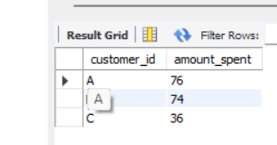

1. How many days has each customer visited the restaurant?

select customer_id, count(Distinct order_date) as visit_days from sales group by customer_id;

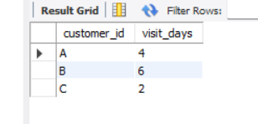

1. What was the first item from the menu purchased by each customer?

select customer_id, product_name from

(

select s.customer_id, s.order_date, m.product_name,

dense_rank() over (partition by customer_id order by order_date) as order_ranks from

sales as s join menu as m on s.product_id= m.product_id

)abc

where order_ranks = 1

group by customer_id, product_name;

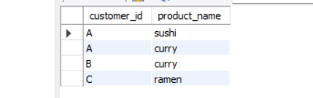

1. What is the most purchased item on the menu and how many times was it purchased by all customers?

with most_popular_cte as (

SELECT (COUNT(s.product_id)) AS most_purchased, product_name, s.product_id

FROM sales AS s

JOIN menu AS m

ON s.product_id = m.product_id

GROUP BY s.product_id, product_name

ORDER BY most_purchased DESC

limit 1)

select customer_id, product_name, count(s.product_id) as counter from sales as s join most_popular_cte as m

on s.product_id = m.product_id

group by customer_id;

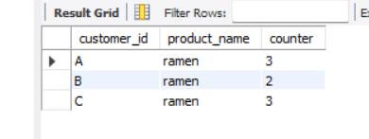

1. Which item was the most popular for each customer?

WITH fav_item_cte AS

(

SELECT s.customer_id, m.product_name,

COUNT(m.product_id) AS order_count,

DENSE_RANK() OVER(PARTITION BY s.customer_id

ORDER BY COUNT(s.customer_id) DESC) AS ranker

FROM menu AS m

JOIN sales AS s

ON m.product_id = s.product_id

GROUP BY s.customer_id, m.product_name

)

SELECT customer_id, product_name, order_count

FROM fav_item_cte

WHERE ranker = 1;

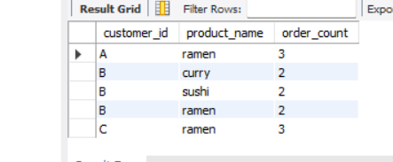

1. Which item was purchased first by the customer after they became a member?

select s.customer_id, first_value(s.product_id) over (partition by customer_id)

as product_id, me.product_name

from sales as s join members as m on s.customer_id = m.customer_id

join menu as me on s.product_id = me.product_id

where m.join_date <= s.order_date

group by customer_id;

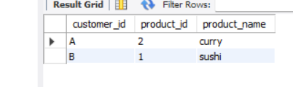

1. Which item was purchased just before the customer became a member?

WITH prior_member_purchased_cte AS

(

SELECT s.customer_id, m.join_date, s.order_date, s.product_id,

DENSE_RANK() OVER(PARTITION BY s.customer_id

ORDER BY s.order_date DESC) AS ranker

FROM sales AS s

JOIN members AS m

ON s.customer_id = m.customer_id

WHERE s.order_date < m.join_date

)

select p.customer_id, p.order_date, m.product_name from prior_member_purchased_cte as p

join menu as m on m.product_id = p.product_id

where ranker = 1

order by customer_id;

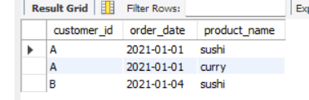

1. What is the total items and amount spent for each member before they became a member?

select s.customer_id, count(m.product_id) as Total_items, sum(price) as amount_spent

from sales as s join menu as m on s.product_id = m.product_id

join members as me

on s.customer_id = me.customer_id

where s.order_date < me.join_date

group by s.customer_id

order by s.customer_id;

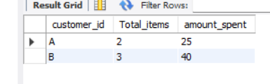

1. If each $1 spent equates to 10 points and sushi has a 2x points multiplier - how many points would each customer have?

WITH price_points AS

(

SELECT *,

CASE

WHEN product_id = 1 THEN price * 20

ELSE price * 10

END AS points

FROM menu

)

SELECT s.customer_id, SUM(p.points) AS total_points

FROM price_points AS p

JOIN sales AS s

ON p.product_id = s.product_id

GROUP BY s.customer_id;

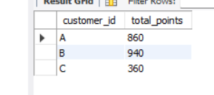

1. In the first week after a customer joins the program (including their join date) they earn 2x points on all items, not just sushi - how many points do customer A and B have at the end of January?

select dateadd(day, 6, "2021-01-02");

WITH dates_cte AS

(

SELECT *, DATEADD(DAY, 6, join_date) AS valid_date,

EOMONTH('2021-01-31') AS last_date

FROM members AS m

)

SELECT d.customer_id, s.order_date, d.join_date,

d.valid_date, d.last_date, m.product_name, m.price,

SUM(CASE

WHEN m.product_name = 'sushi' THEN 2 * 10 * m.price

WHEN s.order_date BETWEEN d.join_date AND d.valid_date THEN 2 * 10 * m.price

ELSE 10 * m.price

END) AS points

FROM dates_cte AS d

JOIN sales AS s

ON d.customer_id = s.customer_id

JOIN menu AS m

ON s.product_id = m.product_id

WHERE s.order_date < d.last_date

GROUP BY d.customer_id, s.order_date, d.join_date, d.valid_date, d.last_date,

m.product_name, m.price;

## Bonus Questions

### Join All The Things

The following questions are related creating basic data tables that Danny and his team can use to quickly derive insights without needing to join the underlying tables using SQL.

Recreate the following table output using the available data:

| **customer_id** | **order_date** | **product_name** | **price** | **member** |
| --- | --- | --- | --- | --- |
| A | 2021-01-01 | curry | 15 | N |
| A | 2021-01-01 | sushi | 10 | N |
| A | 2021-01-07 | curry | 15 | Y |
| A | 2021-01-10 | ramen | 12 | Y |
| A | 2021-01-11 | ramen | 12 | Y |
| A | 2021-01-11 | ramen | 12 | Y |
| B | 2021-01-01 | curry | 15 | N |
| B | 2021-01-02 | curry | 15 | N |
| B | 2021-01-04 | sushi | 10 | N |
| B | 2021-01-11 | sushi | 10 | Y |
| B | 2021-01-16 | ramen | 12 | Y |
| B | 2021-02-01 | ramen | 12 | Y |
| C | 2021-01-01 | ramen | 12 | N |
| C | 2021-01-01 | ramen | 12 | N |
| C | 2021-01-07 | ramen | 12 | N |

select s.customer_id, s.order_date, m.product_name, m.price,

case when s.order_date >= me.join_date then "Y"

else "N"

end as members

from sales as s left join menu as m

on s.product_id = m.product_id

left join members as me

on me.customer_id = s.customer_id

order by s.customer_id;

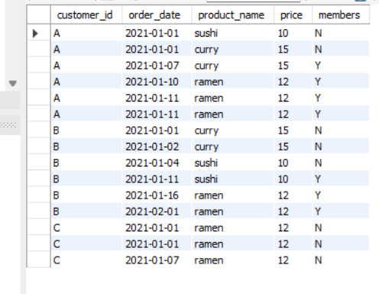

### Rank All The Things

Danny also requires further information about the ranking of customer products, but he purposely does not need the ranking for non-member purchases so he expects null ranking values for the records when customers are not yet part of the loyalty program.

| **customer_id** | **order_date** | **product_name** | **price** | **member** | **ranking** |
| --- | --- | --- | --- | --- | --- |
| A | 2021-01-01 | curry | 15 | N | null |
| A | 2021-01-01 | sushi | 10 | N | null |
| A | 2021-01-07 | curry | 15 | Y | 1 |
| A | 2021-01-10 | ramen | 12 | Y | 2 |
| A | 2021-01-11 | ramen | 12 | Y | 3 |
| A | 2021-01-11 | ramen | 12 | Y | 3 |
| B | 2021-01-01 | curry | 15 | N | null |
| B | 2021-01-02 | curry | 15 | N | null |
| B | 2021-01-04 | sushi | 10 | N | null |
| B | 2021-01-11 | sushi | 10 | Y | 1 |
| B | 2021-01-16 | ramen | 12 | Y | 2 |
| B | 2021-02-01 | ramen | 12 | Y | 3 |
| C | 2021-01-01 | ramen | 12 | N | null |
| C | 2021-01-01 | ramen | 12 | N | null |
| C | 2021-01-07 | ramen | 12 | N | null |

WITH summary_cte AS

(

SELECT s.customer_id, s.order_date, m.product_name, m.price,

CASE

WHEN mm.join_date > s.order_date THEN 'N'

WHEN mm.join_date <= s.order_date THEN 'Y'

ELSE 'N' END AS member

FROM sales AS s

LEFT JOIN menu AS m

ON s.product_id = m.product_id

LEFT JOIN members AS mm

ON s.customer_id = mm.customer_id

)

SELECT *, CASE

WHEN member = 'N' then NULL

ELSE

RANK () OVER(PARTITION BY customer_id, member

ORDER BY order_date) END AS ranking

FROM summary_cte;

